CONNECTION DETAILS OF RADIX 2 WIRE RH+T TRANSMITTER TYPE SC807 WITH DIGITAL METER TYPE RADIX X96A

(1) Sensor Brown Colour Wire Connect to Digital Meter Terminal No.10

(2) Sensor Blue Colour Wire Connect to Digital Meter Terminal No.14

(3) Sensor Black Colour Wire Connect to Digital Meter Terminal No.34

(4) Setting input 1 & 2 = 4 to 20 mAmp

(5) Input 1 High = 100

(6) Input 2 High = 50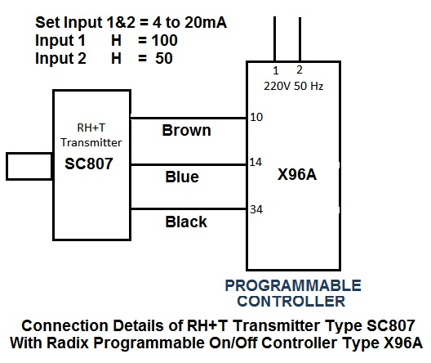
(Drawn By Mr. Adeeb Raza)

