HINDUSTAN GLASS WORKS LTD. Software Reloading in Flash Ram Card of Spacer Bending Machine
Software Reloading: - Spacer Bending Machine Flash Ram Card is fixed on the Left hand side of the Touch Screen Panel in the Flash Ram Socket. Follow the steps as given here with.
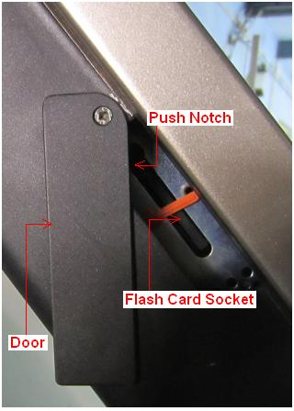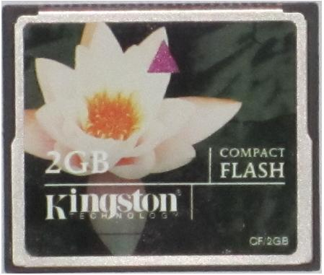
FLASH RAM CARD SOCKET SEE FLASH RAM CARD OF 2GB
See (fig 1) PVI Transfer & (Fig 2) Generate Compact Flash
- To Remove 2 GB Flash Ram Card from Socket Push to the Notch
- Put 2 GB Flash Ram Card in the USB Flash Card Reader
- Connect USB Cable of USB Flash Card Reader to your Computer
- Click here to Download Original Software from Internet & unzip the file SBM-CNC.zip.
- You will get a folder hjpbfin
- You will get Spacer Bending Machine unzipped software in the folder named hjpbfin
- Double click on folder hjpbfin and see the file name PVITransfer.exe
- Double click on icon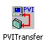PVITransfer.exe to RUN the Transfer Program
- Click on Generate Compact Flash →Point No. (1) in the fig
- Click on Browse & Select File HJPBFIN.pil → Point No.(2) in the fig
- See Path \hjpbfin\ HJPBFIN.pil
- Click on Select Disk → Point No. (3) in the fig
- Select Flash Card Drive
- Click on Generate disk → Point No. (4) in the fig
- After Transfer Data Click on Close → Point No. (5) in the fig
- Now close the Flash Card Reader & remove USB Cable of Flash Card Reader from you
- Computer.
- Remove 2GB Flash Card from Flash Card Reader
- Remember that Spacer Bending Machine power is OFF
- Now put 2GB Flash Card on Spacer Bending Machine → Flash Ram Card Socket is fixed on the Left hand side of the Touch Screen Panel in the Flash Ram Socket.
- Now Power ON Spacer Bending Machine & watch the booting process
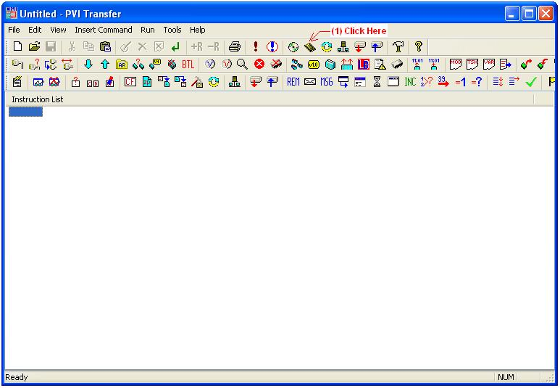

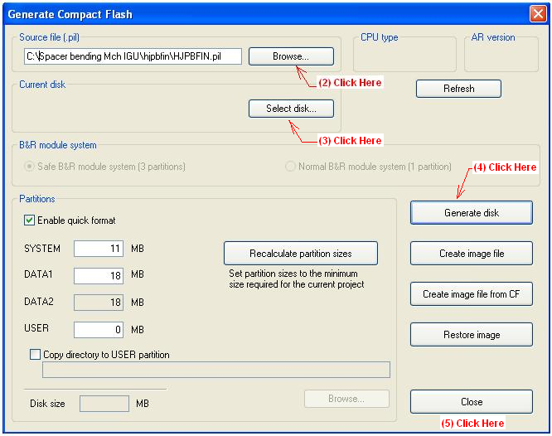
Note: - What is the work of Generate Compact Flash Wizard & sub Menus ---------→ To load HJPBFIN.pil file in your computer’s memory to do the task
- HJPBFIN.pil utility tool will do three jobs as given following
- Partitions of Flash Memory Card in to four part named (a) SYSTEM →11MB (b) DATA1→18MB (c) DATA2→ 18MB (d) USER→ 0MB
- Format all Partitions to use & store data in it
- Transfer DATA from your computer to Flash Card 2GB in defined partitions as per requirement of Spacer Bending Machine to work properly.

Now Spacer Bending Machine is ready to work.

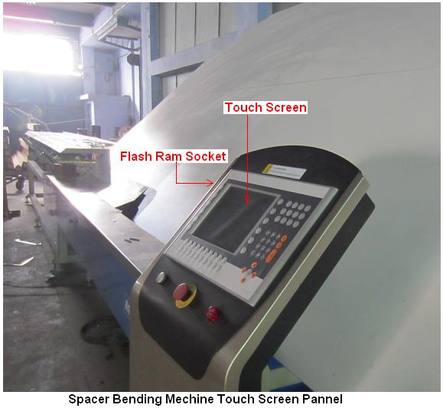

By Mr. Adeeb Raza
******************************* THE END ***********************************

